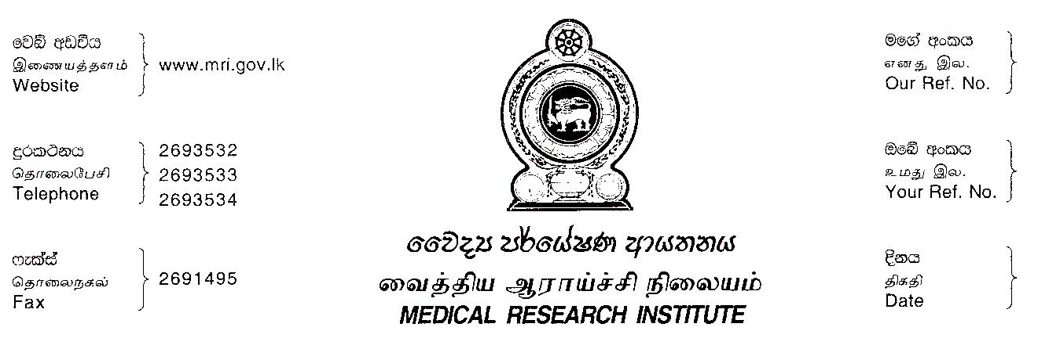

2023.03.01

Regional Director of Health Services,

Kaluthara.

**Special Entomology Research Survey – March 2023**

Department of Entomology/**MRI** has planned to carry out Entomological Research surveys in wadduwa M.O.H. area of Kalutara district from **07th to 16th March 2023.**

The following officers are involved in sampling and data collection activities in the field from **07th to** **16th March, 2023**.

|  |  |  |  |
| --- | --- | --- | --- |
|  | **NAME** | **DESIGNATION** | **ID NUMBER** |
| 01 | N.T. Jayashigha | Health Entomology Officer | 622334038V |
| 02 | U.L.P.Rangana | Health Entomology Officer | 873473495V |
| 03 | G.S.T.Wimalasena | Health Entomology Officer | 880490338V |
| 04 | M.P.R.Sameera | Health Entomology Officer | 900173075V |
| 05 | E.U. Hewawitharanage | Health Entomology Officer | 198805500160 |
| 06 | I.P.R.Samarasekara | Health Entomology Officer | 891071299V |
| 07 | C.B.S.Piris | Field Attendant | 196533803240 |
| 08 | U.D.J.Pushpakumara | Field Attendant | 763591115V |
| 09 | H.A.B.L. Perera | Health Aid | 912340090V |

If you have any queries about the field component of the research, don't hesitate to get in touch with Mr. Nalin, Health Entomology Officer, at 0702003842.

Your cooperation on this is greatly appreciated.

……………………….

Director/M.R.I.

Copy- MO/MOH (Wadduwa) – For Information please

|  |
| --- |
|  |